Chapter 22. Soil Treatments For the Reduction of Plant Pathogens:

Although farmers and growers try their best to prevent the entrance of pests and pathogens into their system, oftentimes these insidious organisms can creep in. Hence the importance of routine scouting and monitoring of plants for crop health. Early detection of these invaders can result in much more successful control or even elimination of unwanted pests. However, if producers find themselves in a position where they already have some degree of pest pressure, there are still steps one can take to mitigate further issues.
Depending on the style of grow or farm in question my dictate which approaches are used; for instance a farm growing in living soil would have different options than a hydroponic farm growing in rockwool. Hydroponic mediums are often not reused. Hydroponic operations that successfully do so generally sanitize/sterilize and rinse the media of salt build-up before reuse. This can be a highly efficient strategy with media such as inert pelletized clay (ex. Hydroton) or perlite. Farmers growing in fields do not have this same absolute control over their media, or even that of soil growers in pots. We focus here on methods of repairing and improving soils so that disease organisms are eliminated or minimized, as is the damage to a farmers crop. The methods we outline can be used to ‘reset’ any soil that is currently causing issues with plant health.

Steam sterilization/pasteurization

Steam pasteurization and sterilization are effective ways to decrease pathogen populations and can be used to rehabilitate pathogen infested soil (Trevors 1996, Wolf 1989). Various machinery exists to perform large scale soil steaming (Fig. 1). The goal of soil pasteurization is to rid soils of pathogens, while maintaining some of the beneficial soil microbiota and not significantly altering the chemical or physical properties of the soil (Trevors 1996). Soil that is fully sterilized is more susceptible to pathogen invasion, and should be inoculated with beneficial saprophytes as soon as it cools (Malowany and Newton 1947). Small scale soil sterilization and pasteurization can be performed on the stove top in pots and pressure cookers, or slightly larger scale in metal drums on propane burners.

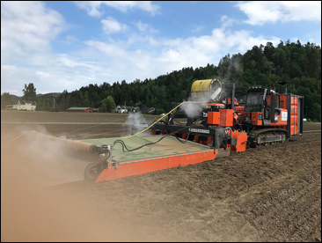
Figure 22.1. Farm machinery equipped for deep soil steaming.

Table 22.1. Field techniques for steaming soil.
Steaming Method: | Description
Sheet | A large, heat resistant, insulated sheet is used to cover an area of soil. Steam is injected under the sheet and allowed to percolate through the soil for a period of time.
Depth | An area of soil is covered with a sheet, as in sheet steaming. However, permanent or temporary piping is used to create a negative pressure at depth in the soil in order to pull hot steam deeper
Hood | Hoods are steam treatment devices that operate as surface steamers (like sheet steaming). The treatment area is limited to the size of the hood.
Sandwich | Sandwich steamers are hoods that combine surface and depth steam treatment under forced pressure. This is the fastest and most efficient soil steaming method.

Solarization

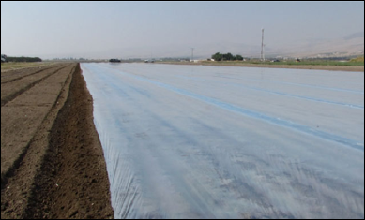
Figure 22.2 Soil solarization using plastic sheeting

Soil solarization is a non-chemical, passive strategy to eliminate or reduce soil pathogens using sunlight energy. This can have numerous benefits over other soil treatment methods due to low cost and ease of implementation while at the same time effectively decreasing populations of pathogenic organisms. However, this method is non-selective and will kill beneficial microbiota as well as the pathogens.
Soil is typically watered and then covered with clear or black plastic (polyethylene) to cover large areas of soil in the field during sunny, warm weather (Stapleton 2000). Heat is trapped under the plastic, pasteurizing or sterilizing the soil up to 18 inches deep. There are a number of variables that affect the efficacy of these treatments such as soil moisture, temperature (soil and air), solar radiation, wind speed, etc. (Stapleton 2000). Heat from solarization can greatly reduce or eliminate many pathogenic soil fungi, nematodes, and weed seeds. Incorporation of green manures, composts, and organic additives alongside soil solarization may increase its effectiveness.
http://ipm.ucanr.edu/PMG/PESTNOTES/pn74145.html
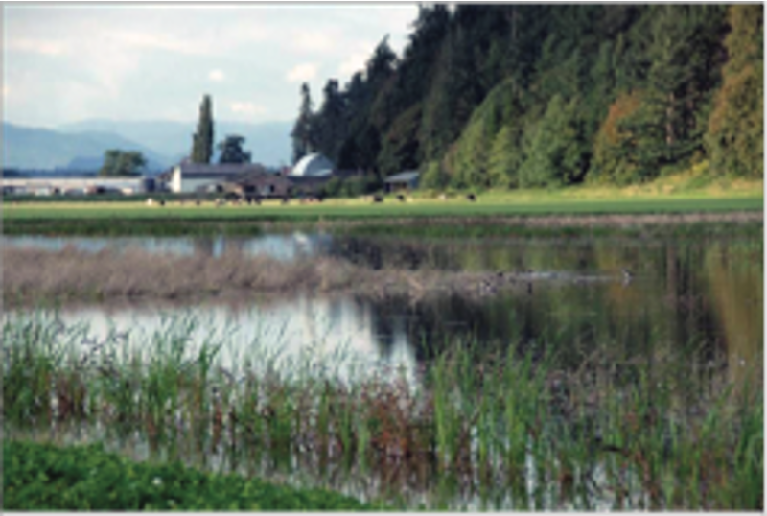
Figure 22.3. Flooded potato field in Skagit, Wa. This field was flooded to assess the efficacy of field flooding in decreasing pathogenic fungal populations.

Flooding
Flooding can effectively reduce some soil pathogens, including Fusarium, Verticillium, Sclerotina, and Pythium. Flooding quickly causes anaerobic conditions in soil which greatly limits the ability of aerobic soil fungi to survive (Newhall 1955). Soil should be flooded for an extended period (at least 2 weeks) to effectively reduce most pathogens. Flooding poses a risk of spreading soil-borne pathogens, particularly those with mobile zoospores, including oomycetes. Flooding should be performed during times where risk of nutrient leaching is low.
https://research.libraries.wsu.edu/xmlui/bitstream/handle/2376/4836/EM056E.pdf?sequence=2&isAllowed=y

Green manures

Green manures are cover crops whose biomass is incorporated into the soil. Cover crops are commonly used to reduce erosion, control weed growth, improve soil structure, improve water retention, and add soil nutrition (such as nitrogen fixation from a legume cover crop). In addition to these benefits, tilling in green manures can reduce soil-borne pathogens by encouraging a robust community of soil saprophytes. A strong saprophyte community will make it difficult for the propagules of pathogens to survive in dormancy or periods of facultative saprophytic growth during times without appropriate host plants. No-till farmers who chop and drop cover-crops still experience many of the benefits of green manures, though incorporation into soil increases their usefulness as soil treatment for the purpose of reducing pathogenic microorganisms in infested soil. Incorporation will increase soil microbial activity.
Cover crops are usually legumes, grasses, or brassicas. You can plant cover crops any time of the year where it is warm enough for plant growth. It is important to cut or plow cover crops before they set seed to prevent reseeding. Legumes can greatly increase available nitrogen for the subsequent cash crop due to their association with nitrogen fixing rhizobia.
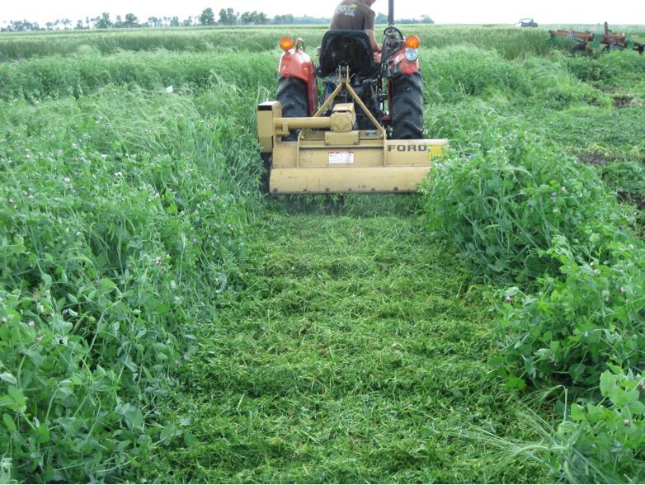
Figure 22.4. Green manure being terminated by mowing down. This can then be incorporated back into the soil or left as a mulch layer.

Brassica Plow Down Crops:

Brassica plow-down crops are a specific category of green manures with anti-pathogenic activity beyond increased activity of saprophytic soil microbiota as they decompose the plant material. Brassicas, commonly known as mustards, contain glucosinolates, which are responsible for their hot and peppery taste. Glucosinolates break down to release isothiocyanates -the primary active chemical responsible for Brassica plow-down crop’s biocontrol properties. Some readers may be familiar with isothiocyanates already as a result of their well publicized anticancer properties. Due to the volatile nature of isothiocyanates, cover crop management and proper soil conditions during plow under are crucial for effective biocontrol; if the plow down crop isn’t immediately worked into moist soil the isothiocyanate will blow away with the wind before performing its role as a soil fungicide.
Brassica plow-down crops are a well established biocontrol strategy for field-level control of a variety of important Cannabis soil pathogens, including Fusarium spp., Pythium spp., Sclerotinia spp., Verticillium spp., and Rhizoctonia spp. Additionally, Brassica plow-down crops can also be used to treat nematodes, insect pests, and weed plants.
Table X. List of Brassica plants that can be used as Brassica plow-down crops.
Broccoli
Kale
Cabbage
Canola
Rapeseed
Radish
Turnip
Various Mustards
** From Larkin and Lynch 2018
Not all Brassicas are equal when it comes to their use for plow-down biocontrol. Cover crop varieties have been specifically developed for high glucosinolate production as well as other characteristics. Choose a variety that will grow well in your location and with the proper characteristics for your pathogen or pest (i.e. the Caliente line). Different varieties have differing amounts and levels of glucosinolates, which are converted into various isothiocyanates when the mustard plant is damaged. The different isothiocyanates have varying biocontrol potential among pathogens and pests.. Allyl isothiocyanate is the chemical mostly responsible for biocontrol when used as a plow-down crop for the suppression of fungal soil borne diseases. Other isothiocyanates are preferred for nematode control.

A.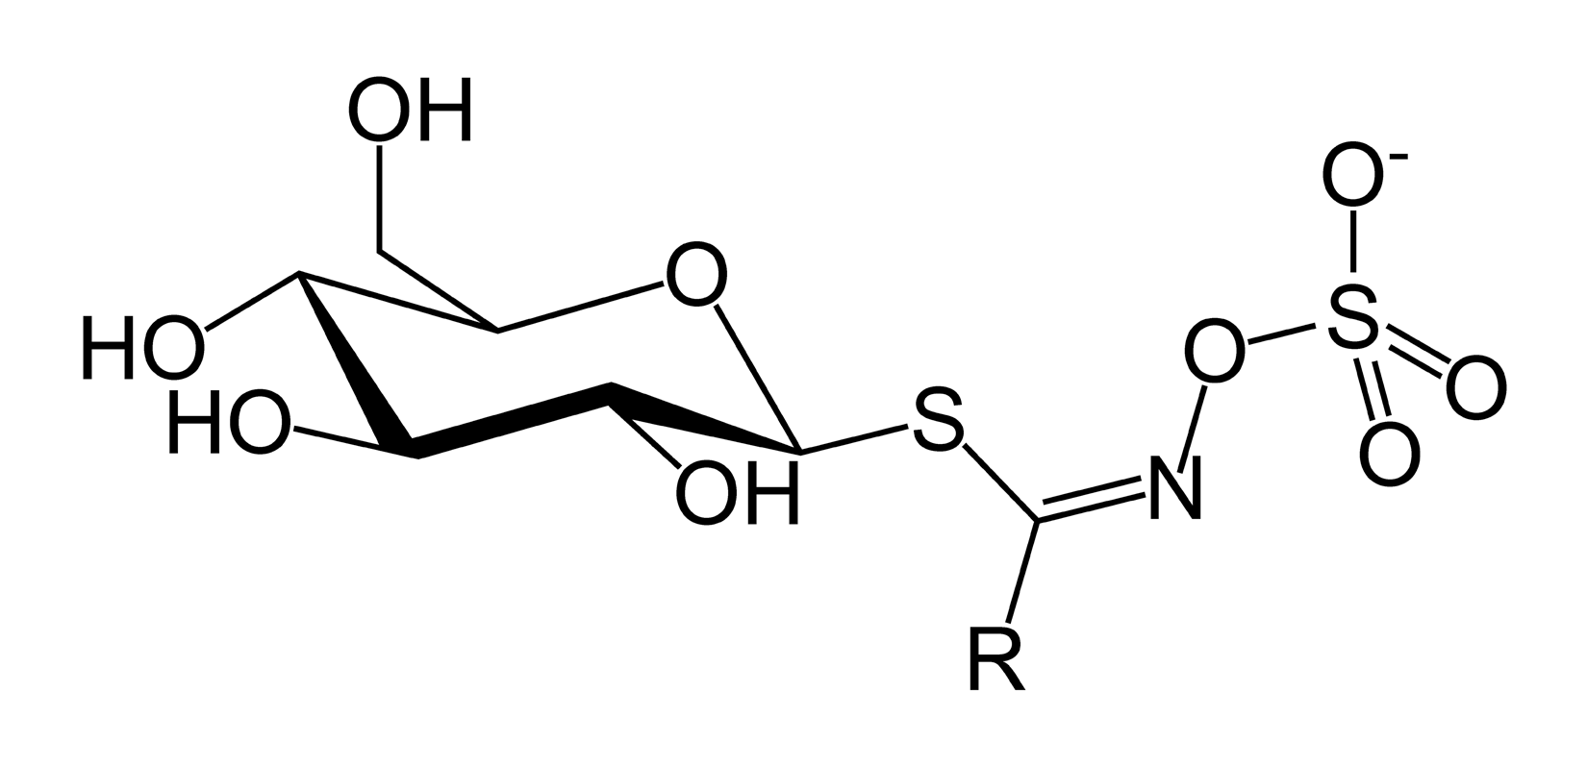 B. 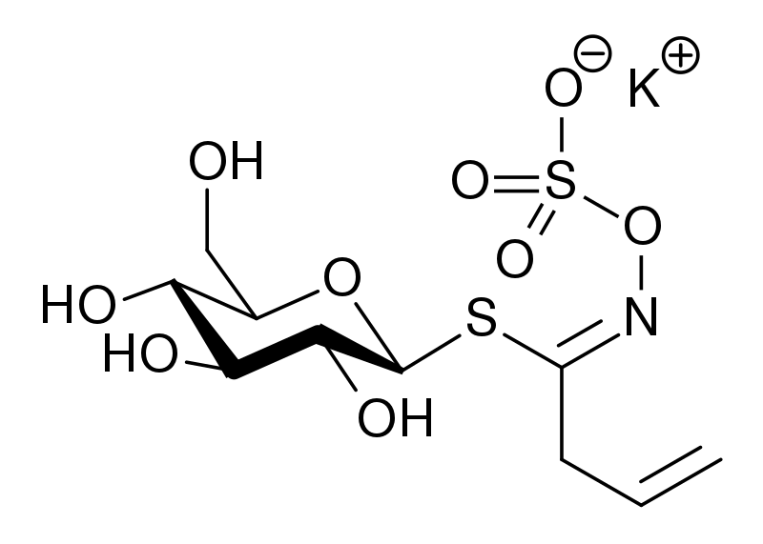

C. 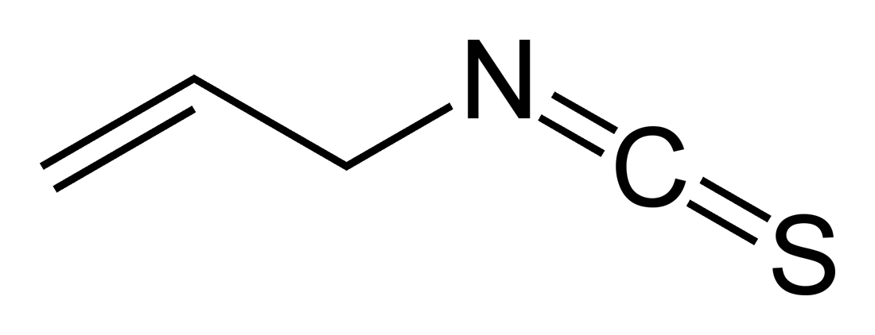

Figure 22.5. A, Glucosinolates are a class of chemicals that are converted to isothiocyanates by the myrosinase enzyme. In the plant, glucosinolates are physically separated from myrosinase. Upon tissue damage they react to release volatile isothiocyanates. B. Sinigrin is the specific glucosinolate that is converted to (C.) Allyl isothiocyanate, the chemical mostly responsible for brassica cover crops biofumigation properties for the control of soil borne fungal pathogens.

Table X. Important factors for successful planting of a Brassica plow-down crop.
Variety: Choose a variety developed for use as a plow-down cover crop that is high in allyl isothiocyanate (Caliente).
Planting: Brassica cover crops can be seeded any time spring-fall in temperate areas, and year round in warmer areas as long as sufficient moisture is available for germination and growth. Planting dates should be early enough to allow proper biomass production before flowering occurs, as plow-under occurs before seed set. About 60-70 days should be sufficient for maximum biomass production.
Cultivation: Nitrogen and Sulfur should be applied in a 6:1 ratio to ensure sufficient biomass and Glucosinolates production within a range of 75-125 lbs N/ acre. The majority of these nutrient applications will become available for the following crop.
Plow-down: Most of the isothiocyanate volatalizes from mowed brassica cover crop within 20 minutes. For this reason avoid hot, dry, sunny weather for the plow down. It is important to till mustard cover crops into moist soil immediately after mowing. For small areas, tarps can be used to lengthen the persistence of isothiocyanate in the treated soil.
Rest: Wait a period of at least 2 weeks before planting the crop plant, longer in cool weather.

Table X. Suggested biological treatment options for soils with known pathogen populations. These can be attempted alone or in combinations, permitted biological inoculations occur after any pasteurization or sterilization treatments.

Mechanism of action: | Treatment options:
Competition for resources | - Organic material can be introduced to encourage competition by resident microbiota  - Steam and/or brassica plow down treatments should be performed first, followed by re-inoculation with an aggressive saprophyte population
Allelopathic antagonism | - Introduce known antagonists to soil directly to destroy pathogen inocula, or following soil treatment to prevent recolonization
Hyperparasites | - Hyperparasites are organisms known to directly attack the pathogen species as a food source  - Introduce known hyperparasites to soil directly to destroy pathogen inocula or to treat emerging outbreaks on cropped plants

Lime or Sulfur to affect pH
Lime and sulfur additions to soil can shift the microbial environment to favor or disfavor certain species. Many (though not all) soil-borne fungal pathogens prefer acidic soils. Fungal pathogens, such as Fusarium and Verticillium, have been successfully controlled by raising soil pH with lime applications. Alternatively, Phymatotrichum, a fungus that causes root rot in Cannabis, only causes problems in alkaline soils. Proper diagnosis of disease causing organisms is of paramount importance before taking action against a soil-borne disease or pest.
Lime refers to several forms of calcium containing compounds which are used to adjust pH and add nutrients to the soil. All forms of lime raise the pH of soil, known as “sweetening,” and may improve structure and fertility of sodic (high sodium) soils. Agricultural lime (CaCO₃) and dolomite lime (CaMg(CO₃)₂) slowly raises the pH of soil via the buffering capacity of carbonate (CO₃-). Hydrated lime (CaOH) and burnt lime (CaO) raise the pH most aggressively, and should be applied cautiously.
Sulfur also can be applied in various chemical states. Of these, elemental sulfur (which microbes oxidize into sulfuric acid within the soil) and sulfuric acid serve to lower the pH of soil, referred to as “souring.” Magnesium sulfate (MgSO₄), potassium sulfate (KSO₄), and gypsum (CaSO₄) have neutral effects in soil.

Table X. Commercial forms of lime and sulfur that may be applied to cultivated field soil or potting mixes. When choosing which additive to use it is important to take into account how it will react in your specific soil environment.

Product common name | Chemical formula | Effect on pH | Speed of action
Agricultural lime | CaCO₃ | + | slow
Dolomite lime | CaMg(CO₃)₂ | + | slow
Hydrated lime | CaOH | + | quick
Burnt lime | CaO | + | quick
Elemental sulfur | S | - | slow
Sulfuric Acid | H2SO₄ | - | quick
Ferrous sulfate | FeS0₄ | - | medium
Gypsum | CaSO₄ | neutral
Magnesium Sulfate | MgSO₄ | neutral
Potassium Sulfate | K₂SO₄ | neutral

Suppressive soils

Some soils have been shown to be suppressive to various soil-borne plant diseases, including Fusarium spp., Rhizoctonia solani, and Phythoptora spp. suppressive soils occur naturally. Cultural methods and soil treatments may be capable of transforming pathogen-conducive soils into suppressive soils. Soils known to be suppressive to certain pathogens can sometimes be used as an inoculant to transform conducive soil. Suppressive soils may result from the presence of specific organisms antagonistic to the pathogen, or may be “generally suppressive,” with their action resulting from a combined effect of a complex soil microbiota.

Applied biological products
The application of biologically rich compost and/or commercial inoculants in lieu of or following the aforementioned soil treatments may also ameliorate soil-borne disease. Biologically rich compost may naturally contain soil suppressive organisms and creates a competitive, diverse environment in which it is difficult for pathogenic species to thrive.

Table 21.X. Examples of commercially available root inoculants. Most are both pathogen antagonists and plant growth promoting species.
Species | Commercial brands
Trichoderma harzianum | Root Shield
Trichoderma aspergillum | Tenet
Trichoderma gamsii | Tenet
Bacillus subtilis | Serenade
Bacillus amyloliquefaciens | DoubleNickle, Hydroguard

